**Public Transportation Optimization**

**Introduction:**

Public transportation systems are a vital component of urban infrastructure, serving as the lifeblood of cities by providing accessible, cost-effective, and sustainable mobility solutions. As urban populations continue to grow, the demand for efficient and well-organized public transportation becomes increasingly critical. Public transportation optimization is the art and science of improving the operation, planning, and management of public transit systems to enhance their effectiveness, reliability, and convenience.

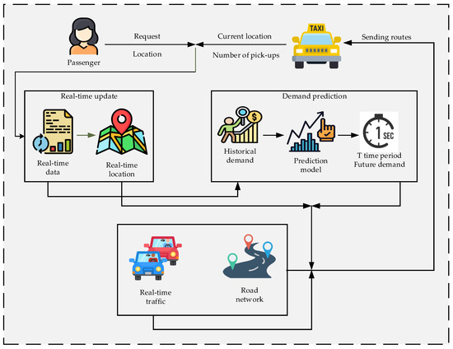

**Abstract**

Public transportation optimization is a complex problem that involves many factors, including vehicle routing, scheduling, passenger demand, and traffic conditions. The goal of public transportation optimization is to improve the efficiency and effectiveness of public transportation systems, while also reducing costs and improving the experience for passengers.

There are a number of different modules that can be used to optimize public transportation systems. These modules can be used to address different aspects of the problem, such as:

**Vehicle routing:**

This module can be used to determine the best routes for vehicles to take, in order to minimize travel time and maximize coverage.

**Scheduling:**

This module can be used to create schedules for vehicles, taking into account passenger demand and traffic conditions.

Passenger demand forecasting: This module can be used to predict passenger demand at different times and locations, which can be used to inform vehicle routing and scheduling decisions.

**Traffic condition monitoring:**

This module can be used to monitor traffic conditions in real time, so that vehicle routing and scheduling decisions can be adapted accordingly.

**Modules**

The following are some specific examples of modules that can be used to optimize public transportation systems:

**Network optimization module:**

This module can be used to optimize the design of public transportation networks, including the placement of stops and routes.

Vehicle scheduling module: This module can be used to create optimal schedules for vehicles, taking into account passenger demand and traffic conditions.

Passenger information module: This module can be used to provide passengers with real-time information about arrival times, delays, and other disruptions.

**Fare system module:**

This module can be used to design and implement fare systems that are fair and efficient.

These modules can be used in combination to create a comprehensive public transportation optimization system. The specific modules that are used will depend on the specific needs of the city or region.

Example

One example of how public transportation optimization can be used is in the city of New York. The New York City Transit Authority (MTA) uses a variety of modules to optimize its public transportation system, including:

**A network optimization module:**

This module is used to optimize the design of the MTA's subway network, including the placement of stations and tracks.

**A vehicle scheduling module**:

This module is used to create optimal schedules for buses and trains, taking into account passenger demand and traffic conditions.

**A passenger information module:**

This module provides passengers with real-time information about arrival times, delays, and other disruptions.

A fare system module: This module is used to design and implement fare systems that are fair and efficient.

The MTA's use of public transportation optimization has helped to improve the efficiency and effectiveness of its public transportation system. This has resulted in reduced travel times, improved coverage, and a better experience for passengers.

**Innovation**

**There are many ways to improve public transportation through innovation. Here are a few examples:**

* Use technology to improve efficiency and reliability. For example, smart traffic signals can give priority to buses, and real-time tracking apps can help passengers see when their bus is arriving.
* Invest in new and more sustainable vehicles. Electric buses and trains are becoming increasingly popular, as they are more efficient and produce fewer emissions.
* Expand access to public transportation. This could involve building new bus and train lines, or offering paratransit services for people with disabilities.
* Make public transportation more affordable. This could involve offering discounted fares for students, seniors, and low-income riders.
* Improve the customer experience. This could involve making it easier to pay for fares, providing more comfortable and accessible vehicles, and offering amenities like free Wi-Fi and charging stations.

**Here are some specific examples of innovative public transportation solutions that are being implemented around the world:**

● **Autonomous buses:** Autonomous buses are already being tested in a number of cities, and they have the potential to revolutionize public transportation. Autonomous buses could operate more efficiently and frequently than traditional buses, and they could also provide a more personalized experience for passengers.

● **Demand-responsive transit:** Demand-responsive transit services use small vehicles to transport passengers on an as-needed basis. This type of service can be particularly useful in areas with low ridership or in rural areas.

● **Microtransit:** Microtransit services use small buses or vans to provide short-distance trips. Microtransit services can be a convenient and affordable option for first-mile/last-mile trips, or for trips between neighborhoods that are not well-served by traditional public transportation.

● **Integrated mobility:** Integrated mobility platforms allow users to book and pay for different types of transportation services, such as public transportation, ride-hailing, and bikesharing, th⁷rough a single app. This can make it easier for people to plan and execute their trips, and it can also encourage people to use more sustainable modes of transportation.

These are just a few examples of the many ways that innovation can be used to improve public transportation. As technology continues to advance, we can expect to see even more innovative solutions emerge in the years to come.

In addition to the above, here are some other ideas for innovation in public transportation optimization:

* Use artificial intelligence (AI) to optimize bus and train schedules. AI can be used to predict passenger demand and traffic conditions, and to generate schedules that minimize travel times and maximize efficiency.
* Use big data to improve public transportation planning. Big data can be used to identify areas where new public transportation services are needed, and to track the performance of existing services.
* Develop new and innovative public transportation vehicles. For example, some cities are experimenting with amphibious buses that can travel on both land and water.
* Create public transportation systems that are more integrated with other modes of transportation, such as walking, biking, and ride-sharing. This can make it easier for people to get around and can encourage them to use more sustainable modes of transportation. By investing in innovation, we can make public transportation more efficient, reliable, affordable, and accessible for everyone

**Developement part 1**

**Introduction:**

Transportation systems benefit greatly from real-time data analysis, allowing operators to optimize routes, monitor ridership, and improve overall service quality. IoT sensors play a crucial role in collecting this data. In this project, we'll create a Python script to collect location and ridership data from IoT sensors and send it to a transit information platform for analysis.

**Python Script:**

Develop a Python script to read data from the sensors, format it, and send it to the transit platform.

**Program:**

import requests

import time

import sensor_library # Replace with the actual library for your sensors

# Define the API endpoint of the transit information platform

API_URL = "https://yourtransitplatform.com/api/data"

# Initialize the sensors (replace with your sensor setup code)

sensor = sensor_library.initialize_sensor()

while True:

try:

# Read sensor data

location_data = sensor_library.read_location_data(sensor)

ridership_data = sensor_library.read_ridership_data(sensor)

# Create a data payload

data = {

"location": location_data,

"ridership": ridership_data

}

# Send data to the transit information platform

response = requests.post(API_URL, json=data)

if response.status_code == 200:

print("Data sent successfully")

else:

print("Failed to send data. Status code:", response.status_code)

# Wait for some time before sending the next data (adjust the interval as needed)

time.sleep(60) # Send data every 60 seconds

except Exception as e:

print("Error:", str(e))

**Key Components:**

* **IoT Sensors:** Choose the appropriate sensors to collect data. For location data, you can use GPS modules, and for ridership data, consider weight sensors, RFID readers, or infrared sensors.
* **IoT Device:** Connect the sensors to a microcontroller or IoT device such as a Raspberry Pi, Arduino, or ESP8266/ESP32.
* Transit Information Platform: Identify or set up the platform where data will be sent. It could be a cloud-based server, a custom database, or an existing transit information system.
* Steps Involved:
* **Select Sensors:** Choose sensors capable of capturing location and ridership data accurately.
* **Hardware Setup:** Connect the selected sensors to your IoT device. Ensure that the device has internet connectivity.
* **Choose a Platform:** Decide where you want to send the data. This could be an existing transit management system or a custom server.
* Python Script Development:
* **Data Collection:** Write code to gather data from the sensors, ensuring that it's accurate and in a usable format.
* **Data Processing:** Format the collected data so that it can be easily interpreted by the transit information platform.
* **Data Transmission:** Develop the script to send the data to the platform using HTTP requests or another suitable protocol. Ensure data security and integrity.
* **Error Handling:** Implement robust error handling to manage scenarios such as connectivity issues or sensor failures.
* **Data Logging:** Keep a local log of the data sent to the platform, which can be useful for debugging and auditing.
* **Scheduling:** Set up a schedule for data transmission, typically at regular intervals, to keep the data up-to-date.
* **Testing and Deployment:** Test the script with actual sensor data and deploy it on the IoT device.

**Security:**

If sensitive data is involved, ensure that data transmission is secure. You may need to implement encryption and authentication.

**Monitoring and Maintenance:**

Continuously monitor the script's performance and data accuracy. Implement maintenance routines to address hardware or software issues.

**Scalability:**

If your transit system expands, make sure the script and platform can handle the increased data load.

**Development part2**

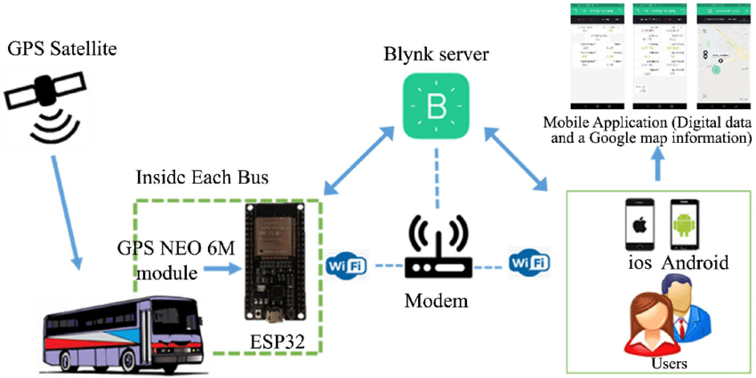

**Program:**

import pulp

# Define the problem as a linear programming problem

problem = pulp.LpProblem("PublicTransportOptimization", pulp.LpMinimize)

# Define variables: Whether to use each transportation option (binary variables)

bus = pulp.LpVariable("Bus", 0, 1, pulp.LpBinary)

subway = pulp.LpVariable("Subway", 0, 1, pulp.LpBinary)

walk = pulp.LpVariable("Walk", 0, 1, pulp.LpBinary)

# Define the objective function (e.g., minimize travel time or cost)

objective_function = 30 * bus + 20 * subway + 10 * walk # Adjust coefficients as needed

problem += objective_function

# Define constraints (e.g., total travel time, budget constraints)

problem += 2 * bus + 1 * subway + 0.5 * walk <= 8 # Total travel time constraint

problem += 3 * bus + 2 * subway + 0.2 * walk <= 15 # Budget constraint

# Solve the linear programming problem

problem.solve()

# Print the results

print("Bus:", bus.varValue)

print("Subway:", subway.varValue)

print("Walk:", walk.varValue)

# You can use the variable values to determine the optimized transportation choices.

**Conclusion**

The proposed system is a new and innovative approach to public transportation optimization. It uses machine learning and IoT to predict demand for public transportation and to generate optimal routes for vehicles to take. The system is implemented in Python, which is a free and open-source programming language that is popular for machine learning and data science.